Dasha Balashova

Dr. Steffen Guenzel

ENC 1102-0000

2 December 2015

Words: 2,308

Research: Media Advertising of Nike, Adidas and Reebok Company in the World Cup.

All fans from all over the world wait every four years for the largest sport event in the world is the World Cup. The World Cup is the soccer tournament where thirty-two national teams are trying to be the champions of the world. Also, the World Cup is a huge arena for sport wear brands to compete. With a hundred of millions of eyes watching this a great sport event, the brands are trying to catch some of that attention as well for their reputation of the marketing. It does not come cheap for the brand, but if the company do it right boosts in sales can be phenomenal for their ranking. Therefore, almost every advertising company, such as Adidas, Reebok, and Nike, wants to sponsor World Cup to increase the ranking of sales and become more popular.

In order to become the sponsor of the World Cup, the organizations try to get the attention from the sport advertising. Ad has long been considered as a way of mass promotion in that just one message can achieve a great number of individuals. This mass promotion approach is improved every single day with new advertising technologies such as using of digital media. Digital media technique is very useful way to catch people attention on the project. Based on the research paper “Nike’s Shanghai Advertising Dialectic: A Case Study” conducted by Cooper S. Wakefield that “the most prominent nonverbal aspect of the ads is eye contact” (Wakefield 69).

In fact, advertising is a productive tool for the business along with its being a significant aspect of the modern age and a quick increasing industry. In addition, the public image of advertising is still a matter of great interest for the companies. Why is it significant for the business? Business is a communication between companies and their audiences, and advertising is a structure of communication, which used to persuade viewers in the ability of product.

After all these analyses, I came to the issue: would people buy the products of famous companies, if the organizations did not have a great advertising? In order to answer this question, I decided to pick top popular three sport companies, which have one of the largest and spectacular advertising productions. There are Nike, Adidas and Reebok. However, among these three organizations, Nike is the first one in the sport advertising industry. According to the article “Shootout: Can Nike Beat Adidas at Soccer” conducted by Brendan Greeley that “Nike is now the largest sportswear company in the world, with $25 billion in revenue and a 17 percent market share. The second-largest, Germany-based Adidas, has $20 billion in revenue and 12 percent of the market” (Greeley 62). As a result, in this dossier paper, I am going to compare each advertising strategy of Nike, Adidas and Reebok, in order to find out the answer how Nike achieved their goal to become the most powerful sports brand in the world. Does Nike have more celebrities in their advertising? Does a great design of Nike advertising play a big role for the influence of customers? Why Adidas and Reebok cannot overtake Nike? All answers on these questions you will find in this research paper that Nike is more successful company to sell their products with using the advertising during the World Cup than Adidas and Reebok together.

The Reebok is a British apparel and athletic footwear organization, which was made officially in 1958 year. However, in 1895, the directors of this company are JW Foster and Sons, who started to sell their products around the United Kingdom, found out that the Reebok company became so popular after the Olympics Games in 1924 year that JW Foster and Sons decided to develop their company in the future. According to the article “The History of Reebok in the Sneaker Industry” conducted by C.Y. Ellis that “the Reebok shoe company is like a streaky jump shooter; when they are hot they are hot, but when they are not nobody is interested” (Ellis 2). The way of “life" as a good management and leadership was always hard for this brand before the developing a new strategy how to have more influence on the customers. Nowadays, the Rebook is returning into his successful place because of a great marketing which is a using of 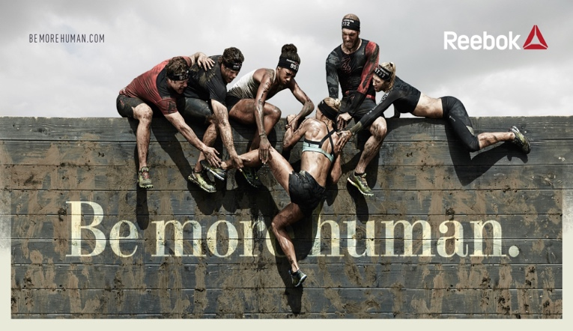the advertising as a business tool of communication between the viewers and the company.

The "Be More Human" is a colossal project which return the fame of the company. This new advertising gave a new inspiration for the Reebok. The company, which lost a good status because of trying to battle with Nike and Adidas to be a sponsor of World Cup, now discovered itself in the global fitness division with a straight goal to change their customers’ perspective of the qualities Reebok's products. The campaign is focused on the strength of CrossFit representatives and other sportsmen to demonstrate that their products, such as sneakers or shorts, are ready to overcome the difficult stages in the life. According to the article “Reebok challenges the world to "Be More Human" with a new brand campaign” conducted by Adgully Bureau that “for people fitness isn’t just a physical activity – it’s something that enhances not only their body, but their entire life. Through fitness they become better parents, better leaders, better teachers, better partners and overall a better, stronger version of themselves” (Bureau 3). The ad "Be More Human" illustrates that athletes can be a little crazy or even crackpot. They always take a position in the dangerous and intense situation, and have a desire to advance beyond their restrictions. In the media advertising, the audience can see how the athletes flip tires, run through flames and do long exercises in the forest. They try to be better and more purposeful in every opportunity which gives them life. Eventually, all these characters try to achieve the point of being more human.

Overall, the Reebok company tries to motivate an audience to change physically, socially and mentally, and Reebok’s products will help to do it. The main tool of their strategy is that the advertising is based on the true stories of people who overcome the difficulties with Reebok’s sportswear.

However, Reebok still needs some support from powerful sportswear companies such as Adidas. In this case, Adidas led the Reebok industry to help them sell their products all over the world. Adidas is one of the largest German multinational organizations which makes sport products. The company was developed by Adi and Rudolf Dassler in 1946, 18 August. The first name of the campaign was Dassler shoes, and after leaving of Rudolf to create his own company, which is now known as Puma. Adi Dassler came up with the successful three black strips as a logo of new industry that is Adidas.

Adidas was always popular among the individuals who love sport. However, they achieved the top only recently with changing their products. Now, the Adidas industry makes footwear and apparel for not only sport, but also daily life. It does not matter who you are athlete, student, employee or just a fashion person, you will find something to wear from Adidas. According to the article “Project Report Adidas” conducted by Obaid Khan that “in 2011, adidas brought together sport, street and style for the first time in one campaign to tell the world what it means to go all in, heart over head, inclusion over ego” (Khan 16). However, the customers did not increase after this news, and then, Dirk Schunberger, who is a creative director of Adidas company, built a strategy to use the advertising as a productive tool for the business. This tool as an art made Adidas shoes a must-have. One of these successful strategies, which increased the number of customers and played a big role for the Adidas industry, was the creation of advertising, “Adidas Originals: SuperStar.”

This advertising is filmed in black-white color, and has 4 celebrities, Beckham, Rita Ora, Pharrell Williams and Damian Lillard. However, these people are trying to explain what it truly 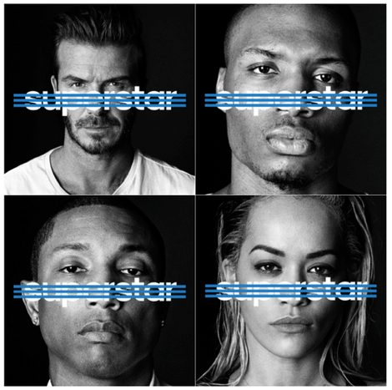means to be a famous person. Money, a big house, or fame are not the meaning of being a superstar. In addition, the Adidas company is considered as a luxurious sport store for famous people. Nevertheless, this advertising indicates that Adidas does not make their products only for famous people, because each person is a superstar and a hero of his own story. The advertising was so successful that it inspires the audience to become this hero of your own life. As a result, the products were sold so fast that the management of Adidas decided to always keep the advertising as a main tool.

All these strategies, which are used by Reebok and Adidas, are no doubt a great way of developing the business, but it still not enough to take out the 1st position from Nike company. During the 1960s, Adidas always held the place of number one among sportswear companies, and dominated the global market around the world. However, according to the article “Adidas: Sprinting Ahead of Nike” conducted by Georgios Dogiamis and Narain Vijayashanker “when Nike became the sponsor of the World Cup in 2002, Adidas lost their position. In the race to be the world leader in sports apparel, adidas trails behind only Nike, which holds a worldwide market share adidas may currently trail behind Nike” (Dogiamis, Vijayashanker 3).

Nike is an American sportswear organization which was founded by Bill Bowerman in 1964. Nike provides their products in 170 countries, and their logo "swoosh" can be identified throughout the world. The swoosh logo was created by Caroline Davidson in 1971. This emblem illustrates the wing of the Greek Goddess Nike, and symbolizes sports and street culture together. The leadership of Nike knows how to attract more customers with a great marketing system which is promoted by the inspired logo and incredible advertising industry that combines all strategies into one. One of these successful ads was “Nike Write The Future.” In 2010, Nike wanted to have an influence on soccer during World Cup and to create the most popular and successful soccer campaign. As a result, they made this short film as an advertising for all countries around the world to bring more people in the world of soccer. This advertising was so successful that it helped to increase the amount of Nike’s costumers twice.

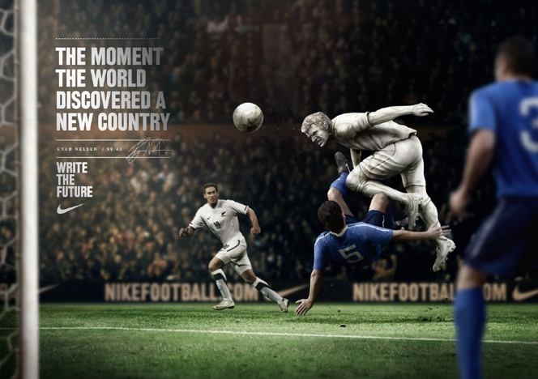The ad “Nike Write The Future” represents a lot of soccer superstars. Nike loves using famous players, as a credibility, to claim to the viewers of soccer fans all over the world or just daily customers. However, the marketing of advertising is focused more on the young customers who represent the national pride, a great motivation, an adventure, the inspiration of watching sport events such as the World Cup, and the achievement of a fame which famous soccer players have in the sport life. As a result, Nike found this person who became the main face of Nike's advertising, and a little hero for the audience. It is Cristiano Ronaldo. He has much better position in the Nike company than other famous players such as Messi, who is a face of Adidas company. In addition, Ronaldo has his own design which calls Mercury. The design is much better and colorful than Adidas, but this is not a reason why Nike is better. The reason is that the advertising makes Cristiano Ronaldo's shoes look amazing and interesting for the viewers, because each story about Cristiano Ronaldo is based on the true story which shows to the audience that Ronaldo was the simple boy, who achieved the fame from the bottom. It does not seem that no body can beat Ronaldo, Nike shows that with Mercury shoes you can achieve more as a soccer player.

In the conclusion, Nike advertises their products by sponsorship contracts with the sport celebrities and national teams in the huge events, such as the World Cup. Also, Nike considers their goods as a premium-brand which has a great design and quality. In order to send the right message about the product to the customers, Nike always uses premiere athletes, such as Cristiano Ronaldo, to promote the goods much faster. The main aim of this company is to be always top of sportswear industry and sell as much as possible products to the customers, and Nike is the number one among the sportswear companies. The reason of this is that they know how to use famous soccer players which have an influence on fans to buy Nike’s products to support the national teams during the World Cup or to write your own future with Nike’s goods. As a result, Nike is more successful company to sell their products with using the advertising than Adidas and Reebok together.

Work Cited

Adidas Originals. “Original Superstar With Pharrell.” Online video clip. *YouTube.* YouTube*,* 30 Jul. 2015. Web. 25 Oct. 2015.

Canton, Mass. "Reebok challenges the world to 'Be More Human' with a new brand campaign." *Adgully* 2015: *General OneFile*. Web. 12 Oct. 2015.

Dogiamis, Georgios. “Adidas: Sprinting Ahead of Nike.” *Mcaffe Journal,* 106 (2010): 1-15. Web. 7 Nov. 2015.

Greeley, Brendan. “Shootout: Can Nike Beat Adidas at Soccer.” *Bloomberg Businessweek Magazine,* 4379(2010):60-56. Web. 4 Nov. 2015.

Kish, Matthew. "Nike and Adidas hit the diamond." *Business Journal-Portland* 2015: 12. *General OneFile*. Web. 12 Oct. 2015.

Low, Elaine. "Amid Nike Wins, Reebok-Adidas Split Said To Be Urged." *Investor's Business Daily* 2014: *General OneFile*. Web. 12 Oct. 2015.

Molly, Creeden. "Adidas Creative Director: Dirk Schunberger." *Details* 2014: *General OneFile*. Web. 12 Oct. 2015.

Neves, Pedro. “Nike Write The Future.” Online video clip. *YouTube.* YouTube, *22* May 2010. Web. 25 Oct. 2015.